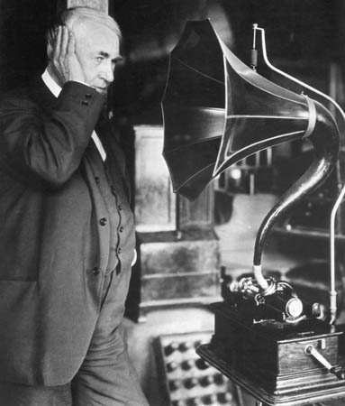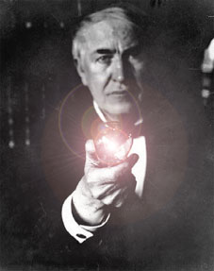**Timeline- Thomas Edison**

For this assignment you will be creating a timeline based on the major events and inventions of Thomas Edison. You must include at least 10 different events/ inventions on your timeline and you are encouraged to add more than 10. At least 6 of those events/ inventions should have pictures on them, with color. You will be graded on effort, not artistic ability. ***Use a separate piece of paper and make it as neat as possible.***

This assignment is worth 10 points.

