**Brochure on Mass Immigration to the US**

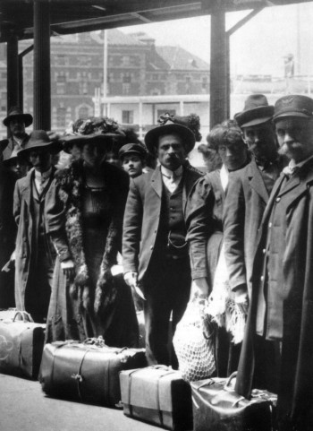 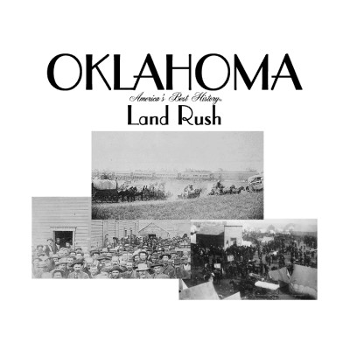 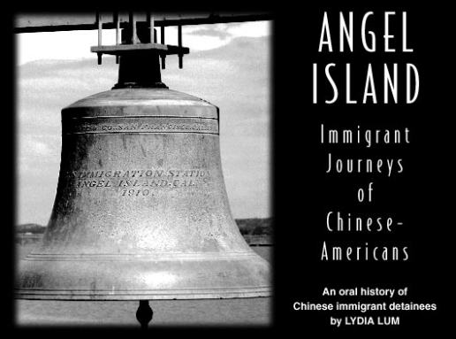

For this assignment you will be creating a brochure about major immigrations to the US. Feel free to provide your own research (it will help your grade) to the assignment. The assignment should be colored and the drawing should be done to the best of your abilities; note: I grade on effort, not how well you can draw. To receive full credit you must have all of the following;

* It must cover Ellis Island/ European immigration, Angel Island/ Asian immigration and the Homestead Act
* All the page must have a picture and color
* Information should be written down ***IN YOUR OWN WORDS!***

***This assignment is worth 20 points.***

**Grading Rubric- Brochure on Mass Immigration**

**Creativity**

6: The brochure shows a great amount of creativity and effort.

5- 4: The brochure shows a good amount of creativity and effort.

3: The brochure shows some creativity and effort.

2: The brochure shows little creativity and/ or effort.

**Color and Pictures**

6: The brochure has great pictures based on the topic and great color on all the pictures.

5- 4: The brochure has good pictures based on the topics and good color on all the pictures.

3: The brochure has OK pictures based on the topic and color on most of the pictures.

2: The brochure is missing pictures and color on some pages.

**Information**

6: The brochure has excellent information based on class discussion and personal research.

5- 4: The brochure has great to good information based on the different topics.

3: The brochure has pretty good information based on the different topics, very little mistakes.

2: The brochure has some good information but there are some major mistakes about the topics.