**The Progressive Era (1890 - 1920)**

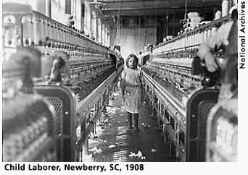Progressivism is the term applied to a variety of responses to the economic and social problems rapid industrialization introduced to America. Progressivism began as a social movement and grew into a political movement. The early progressives rejected Social Darwinism. In other words, they were people who believed that the problems society faced (poverty, violence, greed, racism, class warfare) could best be addressed by providing good education, a safe environment, and an efficient workplace. Progressives lived mainly in the cities, were college educated, and believed that government could be a tool for change. Social reformers, like Jane Addams, and journalists, like Jacob Riis and Ida Tarbel, were powerful voices for progressivism. They concentrated on exposing the evils of corporate greed, combating fear of immigrants, and urging Americans to think hard about what democracy meant. Other local leaders encouraged Americans to register to vote, fight political corruption, and let the voting public decide how issues should best be addressed (the initiative, the referendum, and the recall). On a national level, progressivism gained a strong voice in the White House when [Theodore Roosevelt](http://www.nps.gov/archive/elro/glossary/roosevelt-theodore.htm) became president in 1901. TR believed that strong corporations were good for America, but he also believed that corporate behavior must be watched to ensure that corporate greed did not get out of hand (trust-busting and federal regulation of business). Progressivism ended with [World War I](http://www.nps.gov/archive/elro/glossary/world-war-1.htm) when the horrors of war exposed people's cruelty and many Americans associated President [Woodrow Wilson](http://www.nps.gov/archive/elro/glossary/wilson-woodrow.htm)'s use of progressive language ("the war to make the world safe for democracy") with the war.

http://www.nps.gov/archive/elro/glossary/progressive-era.htm