**Causes of the Civil War APUSH DBQ**

What led to the outbreak of the bloodiest conflict in the history of North America?

A common explanation is that the Civil War was fought over the moral issue of slavery.

In fact, it was the economics of slavery and political control of that system that was central to the conflict.

A key issue was states' rights. The Southern states wanted to assert their authority over the federal government so they could abolish federal laws they didn't support, especially laws interfering with the South's right to keep slaves and take them wherever they wished.

Another factor was territorial expansion. The South wished to take slavery into the western territories, while the North was committed to keeping them open to white labor alone.

Meanwhile, the newly formed Republican party, whose members were strongly opposed to the westward expansion of slavery into new states, was gaining prominence.

The election of a Republican, Abraham Lincoln, as President in 1860 sealed the deal. His victory, without a single Southern electoral vote, was a clear signal to the Southern states that they had lost all influence.

Feeling excluded from the political system, they turned to the only alternative they believed was left to them: secession, a political decision that led directly to war.

http://www.pbs.org/opb/historydetectives/feature/causes-of-the-civil-war/

**Directions**: The following question requires you to construct a coherent essay that integrates your interpretation of Documents A-H **and** your knowledge of the period referred to in the question. High scores will be earned only by essays that both cite key pieces of evidence from the documents and draw on outside knowledge of the period.

*1. “Examine and analyze the causes of the Civil War.”*

**Doc A**

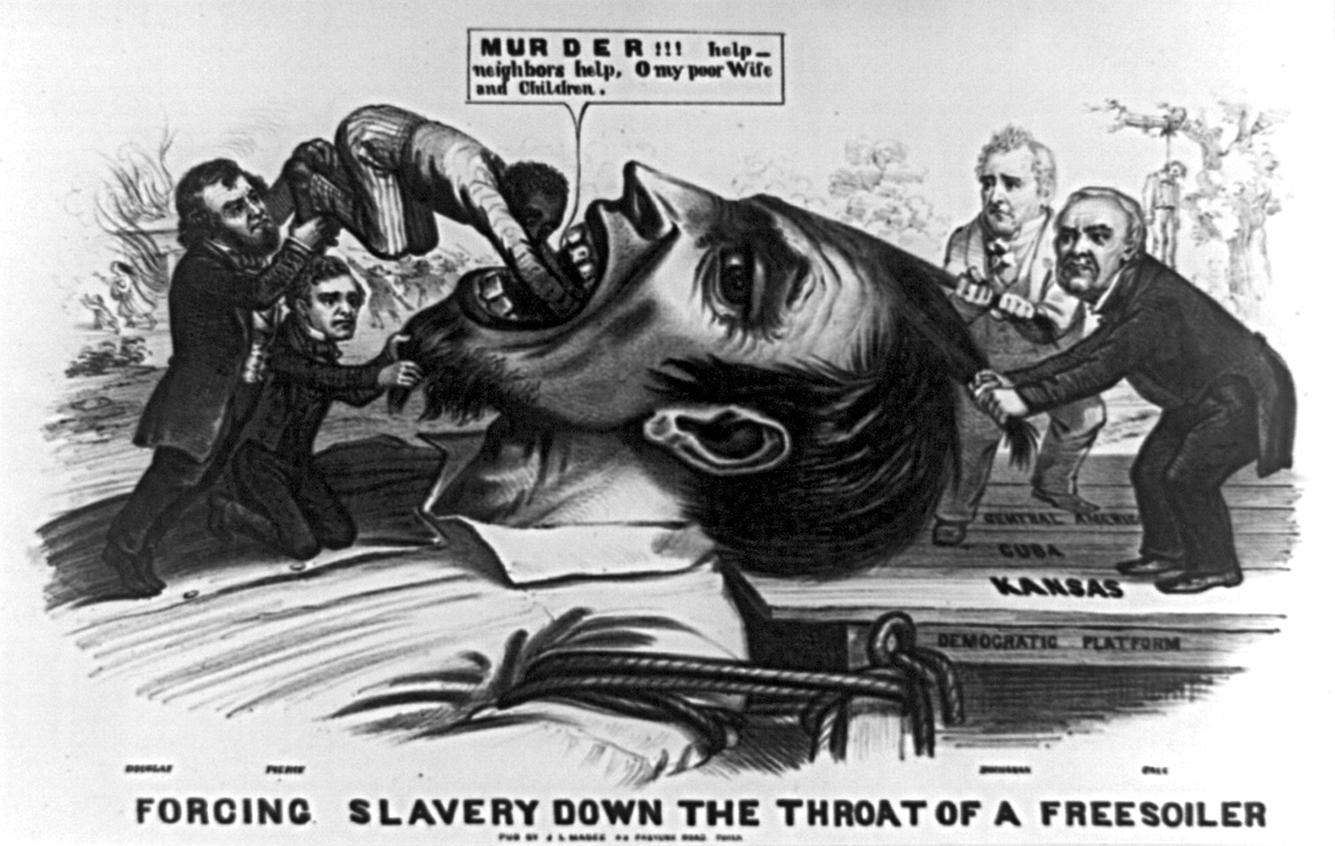

**Doc B**

**November 6, 1860 -** Abraham Lincoln, who had declared "Government cannot endure permanently half slave, half free..." is elected president.

**Dec 20, 1860**- South Carolina secedes from the Union. Followed within two months by Mississippi, Florida, Alabama, Georgia, Louisiana and Texas.

Seven states of the Deep South, those in which the slavery system is most entrenched, leave the Union. Many Southerners favored secession as part of the idea that the states have rights and powers which the federal government cannot legally deny. The supporters of states' rights held that the national government was a league of independent states, any of which had the right to secede.

**Doc C**

*“How in the world can the two things be compared?” said Miss Ophelia. “The English laborer is not sold, traded, parted from his family, whipped.” “He is as much at the will of his employer as if he were sold to him. The slave-owner can whip his refractory slave to death, —the capitalist can starve him to death. As to family security,*

*It is hard to say which is the worst, — to have one’s children sold,*

*Or see them starve to death at home.” “But it’s no kind of apology for slavery, to prove that it isn’t worse than some other bad thing.”*

Harriett Beecher Stowe, Uncle Tom’s Cabin

**Doc D**

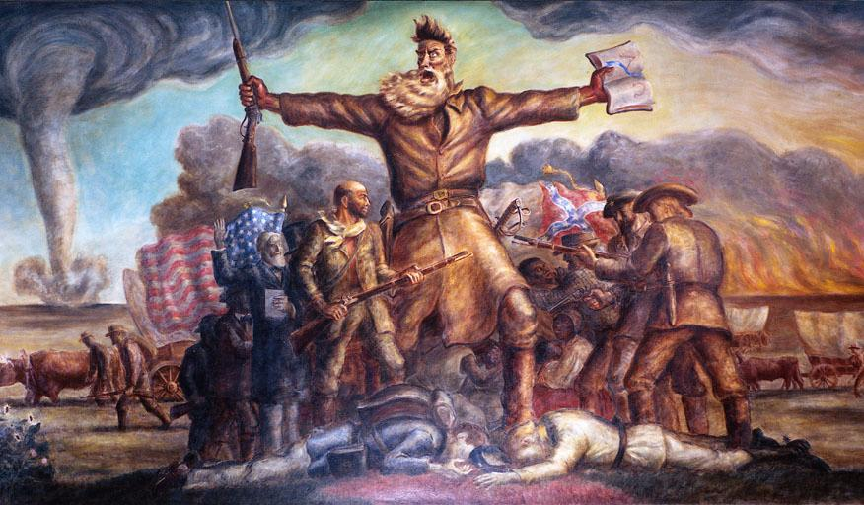

John Brown and the assault on Harper’s Ferry

**Doc E**

**Stephen Douglas: *“****Now, I say to you, my fellow—citizens, that in my opinion, the signers of the Declaration had no reference to the negro whatever, when they declared all men to be created equal. They desired to express by that phrase white men, men of European birth and European descent, and had no reference either to the negro, the savage Indians,… or any other inferior and degraded race, when they spoke of the equality of men. One great evidence that such was their understanding, is to be found in the fact that at that time every one of the thirteen colonies was a slaveholding colony, every signer of the Declaration represented a slaveholding constituency, and we know that no one of them emancipated his slaves, much less offered citizenship to them when they signed the Declaration; and yet, if they intended to declare that the negro was the equal of the white man, and entitled by divine right to an equality with him, they were bound, as honest men, that day and hour to have put their negroes on an equality with themselves.”* (Lincoln v Douglas 3rd Debate)

**Doc F**

**Abraham Lincoln:** *“I will make some answers briefly to certain propositions that Judge Douglas has put. He says, “Why can’t this Union endure permanently, half slave and half free?” I have said that I supposed it could not, and I will try, before this new audience, to give briefly some of the reasons for entertaining that opinion. Another form of his question is, “Why can’t we let it stand as our fathers placed it?” That is the exact difficulty between us. I say, that Judge Douglas and his friends have changed them from the position in which our fathers originally placed it. I say, in the way our fathers originally left the slavery question, the institution was in the course of ultimate extinction, and the public mind rested in the belief that it was in the course of ultimate extinction. I say when this Government was first established, it was the policy of its founders to prohibit the spread of slavery into the new Territories of the United States, where it had not existed. But Judge Douglas and his friends have broken up that policy, and placed it upon a new basis by which it is to become national and perpetual.”* (Lincoln v Douglas 3rd Debate)

**Doc G**

*“Be it good or bad, [slavery] has grown up with our society and institutions, and is so interwoven with them that to destroy it would be to destroy us as a people. But let me not be understood as admitting, even by implication, that the existing relations between the two races in the slaveholding States is an evil:–far otherwise; I hold it to be a good, as it has thus far proved itself to be to both, and will continue to prove so if not disturbed by the fell spirit of abolition. I appeal to facts. Never before has the black race of Central Africa, from the dawn of history to the present day, attained a condition so civilized and so improved, not only physically, but morally and intellectually.”* (Slavery a Positive Good, by John C. Calhoun)

*"But, as it is, we have the* ***wolf by the ear****, and we can neither hold him, nor safely let him go. Justice is in one scale, and self-preservation in the other."*- Thomas Jefferson to John Holmes, (discussing slavery and the Missouri question), Monticello, 22 April 1820. (Necessary Evil)

**Doc H**

*" . . . We think they [people of African ancestry] are . . . not included, and were not intended to be included, under the word "citizens" in the Constitution, and can therefore claim none of the rights and privileges which that instrument provides for and secures to citizens of the United States. . . ."*

— Chief Justice Roger B. Taney, speaking for the majority on the Dred Scott case