|  |
| --- |
| **Angel Island: Immigrates Journeys of Chinese-Americans** |

|  |  |
| --- | --- |
|  | BarrackLike people of other ethnicities, the Chinese immigrated to the United States for better lives. Before 1900, their work included farming, mining and building railroads. Men sent money home to their families in China.  But American laborers resented the Chinese because the latter were willing to work for cheap wages. Americans accused the Chinese of monopolizing jobs.  Stiff immigration laws were passed. Many Chinese immigrants were forced to prove they had a husband or father who was a U. S. citizen or be deported.  From 1910-1940, Chinese immigrants were detained and interrogated at Angel Island immigration station in San Francisco Bay. U.S. officials hoped to deport as many as possible by asking obscure questions about Chinese villages and family histories that immigrants would have trouble answering correctly.  Men and women were housed separately. Detainees spent much of their time in the barracks, languishing between interrogations.  The immigrants expressed their fears and frustrations through messages and poems written or carved into barrack walls. Some poems are still visible at the museum today.  Immigrants were detained weeks, months, sometimes even years. Word got back to China about the prolonged questioning, so people would try to mentally prepare before even crossing the Pacific Ocean.  A 1940 fire destroyed the Angel Island administration building, so the U.S. government abandoned the immigration station. The so-called "Chinese Exclusion Acts" eventually were repealed. Over the years, Chinese have settled in every U.S. city.  Many years have passed. But many Chinese still recall the hardships of detention.  At Angel Island, a museum has been established in the old barracks, re- creating one of the living areas for Chinese detainees. |

<http://www.angel-island.com/history.html>

**Ellis Island Reading**

When Ellis Island opened, a great change was taking place in [immigration to the United States](http://www.history.com/topics/immigration). As arrivals from northern and western Europe--Germany, Ireland, Britain and the Scandinavian countries--slowed, more and more immigrants poured in from southern and eastern Europe. Among this new generation were Jews escaping from political and economic oppression in czarist Russia and eastern Europe (some 484,000 arrived in 1910 alone) and Italians escaping poverty in their country. There were also Poles, Hungarians, Czechs, Serbs, Slovaks and Greeks, along with non-Europeans from Syria, Turkey and Armenia. The reasons they left their homes in the Old World included war, drought, famine and religious persecution, and all had hopes for greater opportunity in the New World.

*“It has been estimated that close to 40 percent of all current U.S. citizens can trace at least one of their ancestors to Ellis Island.”*

After an arduous sea voyage, many passengers described their first glimpse of [New Jersey](http://www.history.com/topics/new-jersey), while third-class or steerage passengers lugged their possessions onto barges that would take them to Ellis Island. Immigrants were tagged with information from the ship's registry and passed through long lines for medical and legal inspections to determine if they were fit for entry into the [United States](http://www.history.com/topics/states). From 1900 to 1914--the peak years of Ellis Island's operation--some 5,000 to 10,000 people passed through the immigration station every day. Approximately 80 percent successfully passed through in a matter of hours, but others could be detained for days or weeks. Many immigrants remained in [New York](http://www.history.com/topics/new-york), while others traveled by barge to railroad stations in Hoboken or Jersey City, New Jersey, on their way to destinations across the country.

Passage of the Immigrant Quota Act of 1921 and the National Origins Act of 1924, which limited the number and nationality of immigrants allowed into the United States, effectively ended the era of mass immigration into New York. From 1925 to its closing in 1954, only 2.3 million immigrants passed through Ellis Island--which was still more than half of all those entering the United States.

Ellis Island opened to the public in 1976. Today, visitors can tour the Ellis Island Immigration Museum in the restored Main Arrivals Hall and trace their ancestors through millions of immigrant arrival records made available to the public in 2001. In this way, Ellis Island remains a central destination for millions of Americans seeking a glimpse into the history of their country, and in many cases, into their own family's story.

http://www.history.com/topics/ellis-island

**Compare and Contrast: Ellis Island and Angel Island**

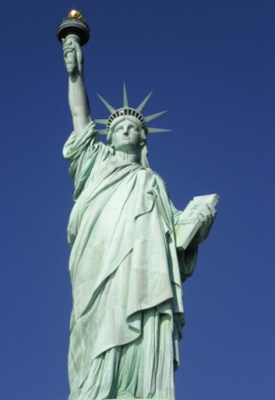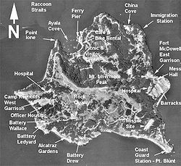

**Ellis Island Angel Island**

**Similar**

Write 8- 10 facts in each category, Ellis and Angel island. Write 4-5 in the similar section.